

**Planning Proposal**

***Rezoning of Land at The Gap Road, Uralla (Lots 29, 61, 119-120, 122-123, 255, 401-409, 415-416, 491 in DP 755846, Lot 1-2 in DP 167083 and Lot B in DP 400556) from RU1 Primary Production to RU4 Small Primary Production Lots***

**February 2018**

Southall” 100 Barney Street

PO Box 1563

ARMIDALE NSW 2350

phone: 02 6772 1077

[email:](mailto:e.agri.gist@southall.org.au)[office@croftsurveying.com](mailto:info@croftsurveying.com)

“

**TABLE OF CONTENTS**

INTRODUCTION ………………………………………………………………………………………………………………………….1

PART 1 OBJECTIVES OR INTENDED OUTCOMES 3

PART 2 EXPLANATION OF PROVISIONS 3

PART 3 JUSTIFICATION 3

*Section A Need for the planning proposal 3*

*Section B Relationship to strategic planning framework 4*

*Section C Environmental, social and economic impact 17*

*Section D State and Commonwealth interests 18*

PART 4 MAPPING 19

PART 5 COMMUNITY CONSULTATION 19

PART 6 PROJECT TIMELINE 22

CONCLUSION……………………………………………………………………………………………………………………………..22

Figures:

Figure 1: Locality Plan

Figure 2: Site

Figure 3: Current land use zones applying to the land

Figure 4: Proposed land use zones applying to the land

Figure 5: Current minimum lot size standards applying to the land

Figure 6: Proposed minimum lot size standards applying to the land

TABLES:

TABLE 1: Applicable actions from New England North West Regional Plan

TABLE 2. KEY ASSESSMENT CRITERIA FOR SMALL RURAL HOLDINGS

TABLE 3: APPLICABLE STATE ENVIRONMENTAL PLANNING POLICIES

TABLE 4: APPLICABLE MINISTERIAL DIRECTIONS (SECTION 117 DIRECTIONS)

TABLE 5: Planning Proposal Process Outline

**Attachments:**

Attachment 1 PHOTOS oF SITE

**INTRODUCTION**

This planning proposal has been prepared in accordance with Section 55 of the *Environmental Planning and Assessment Act 1979* and the Department of Planning and Infrastructure's *"A guide to Preparing Planning Proposals"* (August 2016). The planning proposal seeks to amend the *Uralla Local Environmental Plan 2012* (LEP 2012).

This Planning Proposal relates to Lots 29, 61, 119-120, 122-123, 255, 401-409, 415-416, 491 in DP 755846, Lot 1-2 in DP 167083 and Lot B in DP 400556, The Gap Road, Uralla. It is proposed to rezone the land from RU1 Primary Production to RU4 Small Primary Production Lots and to reduce the current minimum lot size of 200 ha to 20 ha. The proposal seeks to create a more appropriate zoning and lot size that is reflective of emerging nature of the locality and its likely future use.

The Site has a total area of approximately 230 hectares and has the potential for the development of approximately 11 small primary production lots. The location of the Site is shown in Figure 1 and Figure 2.

The Planning Proposal seeks to amend the Zoning and Minimum Lot Size maps applicable to the land.

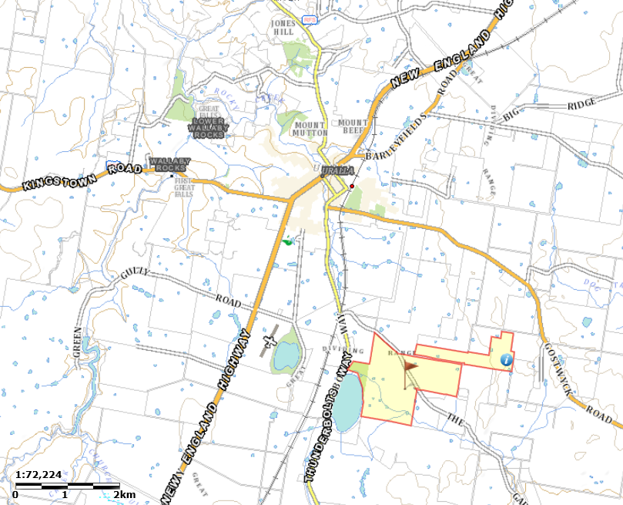

Figure 1: Locality Plan (sourced: SixMaps)

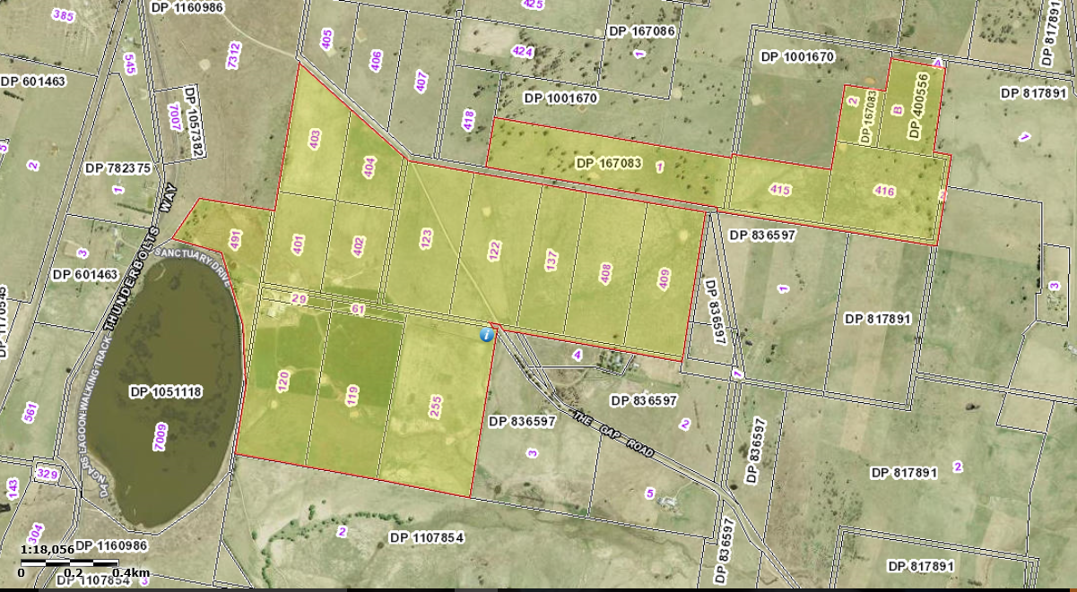

Figure 2: Site (sourced: SixMaps)

**PART 1 – OBJECTIVES OR INTENDED OUTCOMES**

The objectives or intended outcomes of the Planning Proposal are to:

* provide suitable small rural lots that will encourage and promote diversity and employment opportunities related to primary industry and tourism enterprises in a location close to the Uralla township.
* rezone the site so that its zoning is consistent with the existing small primary production land uses adjoining and to the east of the Site.
* alter the lot size standards from 200 ha to 20 ha to be consistent with the existing lot sizes of the Site and to allow for small primary production lots with dwelling entitlements, similar to the lots adjoin and to the east of the Site.

**PART 2 - EXPLANATION OF PROVISIONS**

The proposed outcomes of the Planning Proposal will be achieved by:

* amending the Uralla LEP 2012 Land Zoning Map by rezoning Lots 29, 61, 119-120, 122-123, 255, 401-409, 415-416, 491 in DP 755846, Lot 1-2 in DP 167083 and Lot B in DP 400556 from RU1 Primary Production to RU4 Small Primary Production Lots (refer Figures 3 and 5).
* amending Uralla LEP 2012 Lot Size Map by altering the lot size standards for Lots 29, 61, 119-120, 122-123, 255, 401-409, 415-416, 491 in DP 755846, Lot 1-2 in DP 167083 and Lot B in DP 400556 from 200 ha to 20 ha (refer Figures 3 and 6).

**PART 3 - JUSTIFICATION**

**Section A. Need for the planning proposal.**

**Q1. Is the planning proposal a result of any strategic study or report?**

The subject Planning Proposal is not the direct result of any current strategic study or report by Council or the NSW Department of Planning and Environment.

**Q2. Is the planning proposal the best means of achieving the objectives or intended outcomes, or is there a better way?**

Consideration has been given to alternative methods of achieving the objectives and intended outcomes of the Planning Proposal, including only varying the minimum Lot Size Map within the Uralla LEP 2012. This approach will prohibit uses such as food and drink premises, function centres, and transport and truck depot uses that are suitable on small rural lots and will encourage and promote diversity and employment opportunities related to primary industry and tourism enterprises, particularly those that require smaller lots or that are more intensive in nature.

The proposed rezoning and variation to the MLS standards is considered to be the best means of achieving the objectives or intended outcomes of the Planning Proposal.

**Section B. Relationship to strategic planning framework.**

**Q3. Is the planning proposal consistent with the objectives and actions of the applicable regional or sub-regional strategy (including the Sydney Metropolitan Strategy and exhibited draft strategies)?**

***New England North West Regional Plan 2036***

The New England North West Regional Plan applies to 12 local government areas – Tenterfield, Glen Innes Severn, Inverell, Armidale Regional, Uralla, Walcha, Gwydir, Tamworth Regional, Liverpool Plains, Gunnedah, Narrabri and Moree Plains.

This Plan promotes a holistic approach to land, environmental, water and natural resource management. It aims to maintain the productive capacity of natural resources, improve the agriculture sector’s capacity to cope with changes in markets and weather patterns, and maintain and preserve areas of high environmental value, water catchments and heritage. It provides an overarching framework to guide development and investment in the New England North West to 2036.

**Table 1: Applicable actions from New England North West Regional Plan**

|  |  |
| --- | --- |
| **New England North West Regional Plan** | |
| **GOAL 1 – A strong and dynamic regional economy** | |
| Action | ACTION 1.2 Promote the expansion of agribusiness and associated value-adding activities through local plans. |
| Consistency | The planning proposal seeks to provide suitable small rural lots that will encourage and promote diversity and employment opportunities related to primary industry in a location close to the Uralla township. Therefore, the planning proposal is consistent with this action as it supports the development expansion of agribusiness and associated value-adding activities. |
| Action | ACTION 1.4 Encourage commercial, tourist and recreation activities that complement and promote a stronger agricultural sector, and build the sector’s adaptability. |
| Consistency | The planning proposal seeks to provide suitable small rural lots that will encourage and promote diversity and employment opportunities related to primary industry and tourism enterprises in a location close to the Uralla township. Therefore, the planning proposal is consistent with this action as it supports the development of complementary tourism experiences associated with agriculture. |
| Action | ACTION 3.1 Map important agricultural land and develop guidelines to support the implementation of the important agricultural land mapping through local plans. |
| Consistency | The planning proposal seeks to retain a rural zoning for the Site and aims to provide suitable small rural lots that will encourage and promote diversity and employment opportunities related to primary industries.  The Site is not mapped strategic agricultural land. Therefore, the planning proposal is consistent with this action. |

The relevant priorities for Uralla that build on the directions and actions in this Plan, are listed as follows:

* + *Grow and diversify the local agricultural base by encouraging opportunities for agribusiness and research and development institutions.*
  + *Support emerging boutique food and tourism-based cottage retail enterprises.*

The planning proposal seeks to provide suitable small rural lots that will encourage and promote diversity and employment opportunities related to primary industry and tourism enterprises in a location close to the Uralla township. Rezoning the land to RU4 Small Primary Production Lots is consistent with the existing small primary production land uses adjoining and to the east of the Site. Altering the lot size standards from 200 ha to 20 ha is consistent with the existing lot sizes of the Site and allows for small primary production lots with dwelling entitlements. This will assist in achieving the above priorities.

**Assessment Criteria**

1. **Does the proposal have strategic merit? Is it:**

* **Consistent with the relevant regional plan outside of the Greater Sydney Region, the relevant district plan within the Greater Sydney Region, or corridor/precinct plans applying to the site, including any draft regional, district or corridor/precinct plans released for public comment; or**

The planning proposal is consistent with the relevant actions identified in the New England North West Regional Plan, as discussed in Section B of this report.

* **Consistent with a relevant local council strategy that has been endorsed by the Department; or**

The planning proposal is consistent with the key land use policies and principles for small rural holdings as identified in the New England Development Strategy 2010, as discussed in Section B of this report. This strategy was endorsed by the then Director-General of the Department of Planning and Infrastructure.

* **Responding to a change in circumstances, such as the investment in new infrastructure or changing demographic trends that have not been recognised by existing planning controls.**

The planning proposal will provide for small rural holdings that will allow for the clustering of primary industry and tourism enterprises in a location close to the Uralla township. This will implement Councils objective to increase agricultural and tourism potential and meet demands for small rural holdings. This is consistent with trends identified in the New England North West Regional Plan.

The Uralla LEP 2012 makes provision for 82 hectares of RU4 Small Primary Production Lots. The site will allow for an additional 230 hectares of RU4 zoned land. This additional land is required to meet demand for small rural holdings on appropriately zoned land.

1. **Does the proposal have site-specific merit, having regard to the following:**

* **the natural environment (including known significant environmental values, resources or hazards) and**

The Site has been highly modified for rural purposes. The Site does not contain any significant environmental values, resources or hazards, as discussed in Section C of this report. The land is suitable for the intended small primary production lots.

* **the existing uses, approved uses, and likely future uses of land in the vicinity of the proposal and**

The planning proposal is consistent with the existing small primary production land uses adjoining and to the east of the Site. No surrounding land uses or likely future land uses are incompatible with the proposed RU4 Small Primary Production Lot zoning of the land.

* **the services and infrastructure that are or will be available to meet the demands arising from the proposal and any proposed financial arrangements for infrastructure provision.**

The Site has access to adequate infrastructure for future rural development of the site. Any required upgrading of infrastructure can adequately be addressed as part of the development stage for the subdivision of the land or at the time of future site specific developments.

**Q4. Is the planning proposal consistent with a Council’s local strategy or other local strategic plan?**

***New England Development Strategy (WorleyParsons, 2010)***

The New England Development Strategy (Worley Parsons, 2010) was prepared for Armidale Dumaresq, Guyra Shire, Uralla Shire and Walcha Councils. The New England Development Strategy (NEDS) outlines key land use policies and principles for the four council areas and provides the planning context for preparing LEP provisions. The NEDS has a timeframe of up to 2032.

The NEDS was adopted by the four councils and endorsed by the then Director-General of the Department of Planning and Infrastructure and formed the basis of the Standard Instrument LEPs prepared for the four local government areas, including Uralla LEP 2012.

Part 7 of the NEDS identifies key land use planning issues, including environmental impacts from rural small holdings subdivision and identifies several potential areas for rural small holdings. The land is not within an identified rural small holdings area. The proposed rezoning in the Planning Proposal is justified for the following reasons:

* + The Site is suitable for small primary production purposes in terms of its natural attributes as well as proximity to the Uralla Township.
  + The Site is contiguous with surrounding small primary production lots.
  + The clustering of future small lot primary production and tourism enterprises will encourage and promote diversity and employment opportunities in close proximity to the Uralla township.
* The proposed rezoning is considered to be consistent with the key assessment criteria in the NEDS (page 55) that was used to identify locations for new rural small holdings. Table 2 lists the key assessment criteria and considers the suitability of the site, with a comparison to the identified small rural holding locations. Whilst the Site is not one of the identified potential small rural holding locations identified in the NEDS (Map 7.2, p47), the site is the most consistent with the location criteria listed in the NEDS, as summarised in Table 2 of this report. One of the main justifications for each of the recommended small rural holding locations identified in the NEDS was to expand on the existing small holding settlement patterns in these areas (NEDS, p57-58). The site and its surrounding area is consistent with this justification, as the Site and surrounding area consists of a settlement pattern of small rural holdings.

**Table 2. Key assessment criteria for small rural holdings**

|  |  |  |  |  |  |  |
| --- | --- | --- | --- | --- | --- | --- |
| **Location Criteria** | **Site** | **Invergowrie** | **Rocky River** | **South Arding** | **Saumarez** | **Kentucky** |
| Distance from town – less than 5km | Consistent | Inconsistent | Consistent | Inconsistent | Inconsistent | Inconsistent |
| Provision of services – potable water, electricity. telephone, bushfire services | Consistent | Partially Consistent | Consistent | Partially Consistent | Partially Consistent | Partially Consistent |
| Capacity for onsite water storage – supplementary dam supplies | Consistent | Consistent | Consistent | Consistent | Consistent | Consistent |
| Availability of groundwater and water service | Consistent | Consistent | Consistent | Consistent | Consistent | Consistent |
| Minimal impact on existing infrastructure | Consistent | Consistent | Consistent | Consistent | Consistent | Consistent |
| Good sealed road access | Consistent | Consistent | Consistent | Consistent | Consistent | Consistent |
| Exclude environmentally sensitive land | Consistent | Partially Consistent | Partially Consistent | Consistent | Consistent | Consistent |
| Exclude areas of high bushfire hazard | Consistent | Partially Consistent | Partially Consistent | Partially Consistent | Partially Consistent | Partially Consistent |
| Exclude known mineral and extractive resources | Consistent | Consistent | Inconsistent | Inconsistent | Consistent | Consistent |
| Exclude areas near non-compatible land uses – e.g. sewerage treatment works | Consistent | Consistent | Inconsistent | Consistent | Consistent | Consistent |
| Exclude water supply catchment land | Consistent | Consistent | Consistent | Consistent | Consistent | Inconsistent |
| Avoid areas with threatened species, Endangered Ecological Communities and remanent native vegetation | Consistent | Partially Consistent | Partially Consistent | Consistent | Consistent | Consistent |
| Avoid areas with high soil erosion risk | Consistent | Inconsistent | Inconsistent | Consistent | Consistent | Consistent |
| Avoid forestry land and contaminated land – e.g former orchards sites | Consistent | Consistent | Partially Consistent | Partially Consistent | Partially Consistent | Partially Consistent |
| Avoid areas with soils unsuitable for onsite effluent disposal | Consistent | Partially Consistent | Partially Consistent | Consistent | Consistent | Consistent |
| Avoid flood prone land | Consistent | Consistent | Partially Consistent | Consistent | Consistent | Consistent |
| Avoid Aboriginal and European heritage areas and sites and not detrimentally affect Aboriginal Cultural Landscapes | TBC | TBC | Inconsistent | TBC | TBC | TBC |
| Avoid areas with high groundwater tables | Consistent | Consistent | Consistent | Consistent | Consistent | Consistent |
| Avoid land with slopes greater than 18 degrees | Consistent | Consistent | Partially Consistent | Consistent | Consistent | Consistent |

**Q5. Is the planning proposal consistent with applicable state environmental planning policies?**

Table 3: **Applicable State Environmental Planning Policies**

|  |  |
| --- | --- |
| **State Environmental Policy** | |
| **No. 44 Koala Habitat Protection** | |
| Relevant to Planning Proposal | Yes |
| Application | State Environmental Planning Policy No.44 – Koala Habitat Protection (SEPP 44) aims to encourage the proper conservation and management of areas of natural vegetation that provide habitat for koalas to ensure a permanent free living population over their present range and reverse the current trend of koala population decline. |
| Consistency | SEPP 44 applies to development applications for sites that are over one hectare in area within local government areas listed under Schedule 1 of the policy. Uralla Shire LGA is listed under Schedule 1 of the policy, and the Site has an area of more than one hectare.  The Site has an area greater than 1 hectare and consideration of the policy is required. The sparsely scattered trees located on the northern fringe are unlikely to constitute potential or core koala habitat. This is a matter can be addressed at the DA stage.  The planning proposal is not inconsistent with this SEPP. |
| **No. 55 Remediation of Land** | |
| Relevant to Planning Proposal | Yes |
| Application | SEPP No. 55 introduces State-wide planning controls for the remediation of contaminated land. The policy states that land must not be developed if it is unsuitable for a proposed use because it is contaminated. If the land is unsuitable, remediation must take place before the land is developed. The policy makes remediation permissible across the State, defines when consent is required, requires all remediation to comply with standards, ensures land is investigated if contamination is suspected, and requires councils to be notified of all remediation proposals. To assist councils and developers, the Department, in conjunction with the Environment Protection Authority, prepared Managing Land Contamination: Planning Guidelines. |
| Consistency | Based on the known historical use of the site for grazing and an inspection which did not reveal the remains of any potentially contaminating past activities, it is considered that there is a low likelihood of soil contamination being present on the site.  Anecdotal information from the land owner suggests that a site adjoining the existing wool shed was previously used for cattle or sheep dipping activities that were undertaken within a concrete encased system.  The land is not listed on Council contaminated lands database. It is considered that the land is suitable for rural living purposes and that further investigation at the DA stage focus on potential contamination near the existing wool shed.  The planning proposal is not inconsistent with this SEPP. |
| **No. 64 Advertising and Signage** | |
| Relevant to Planning Proposal | Yes |
| Application | SEPP No. 64 aims to improve the amenity of urban and natural settings by managing the impact of outdoor advertising. The policy responded to growing concerns from the community, the advertising industry and local government that existing controls and guidelines were not effective. SEPP No. 64 offers the comprehensive provisions and consistent approach needed. SEPP 64 – Advertising and Signage: Explanatory Information should be read in conjunction with the policy. |
| Consistency | The planning proposal is not inconsistent with this SEPP. |
| **Rural Lands (2008)** | |
| Relevant to Planning Proposal | Yes |
| Application | The aim of the SEPP is to facilitate the orderly and economic use and development of rural lands for rural and related purposes. This SEPP does not directly relate to the Planning Proposal, however it does provide a number of ‘Rural Subdivision Principles’ and ‘Rural Planning Principals’ to be considered when assessing rural subdivisions and dwellings. |
| Consistency | The Planning Proposal is consistent with the SEPP Rural Lands (2008) as follows:  The rural subdivision principles are listed and addressed below:  *(a) the minimisation of rural land fragmentation,*  The planning proposal seeks to retain a rural zoning for the Site.  The Site and adjoining land to the east of the Site is already fragmented, well below the relevant minimum lot size of 200 ha for dwellings in the immediate surrounding area.  *(b) the minimisation of rural land use conflicts, particularly between residential land uses and other rural land uses,*  The land adjoins other small rural holdings. The planning proposal is likely to reduce the current potential for land use conflict in the area, with the zoning reflecting the predominant small rural holding use in the area.  *(c) the consideration of the nature of existing agricultural holdings and the existing and planned future supply of rural residential land when considering lot sizes for rural lands,*  The site has an area of approximately 230 hectares, consisting of 15 lots with 2 dwelling entitlements. The land to the east of the Site, created in the 1990’s by the Deposited Plan 836597, consists of 6 lots with one 4ha, five ranging from 20 to 25ha and one 40ha. All these lots have dwelling entitlements.  The planned future supply of rural residential land is focussed in the Rocky Creek, Arding, Invergowrie and Kentucky areas. The proposed amendment will not impact on any of these areas, as it is providing the opportunity for small rural holdings with a rural production potential.  *(d) the consideration of the natural and physical constraints and opportunities of land,*  The Site is not identified as bush fire prone or flood affected land. Future development will not require significant native vegetation removal. Soils and slope are suitable for a range of small rural holding uses and the land has the capability for onsite wastewater disposal.  *(e) ensuring that planning for dwelling opportunities takes account of those constraints.*  The Site is considered suitable as discussed above for the proposed zoning and lot size changes and has the capacity to accommodate additional dwellings with no likely adverse impacts.  The rural planning principles are listed and addressed below:  *(a) the promotion and protection of opportunities for current and potential productive and sustainable activities in rural areas.*  The land is already fragmented. The proposed zoning and MLS amendment will not impact the current agricultural use of the land or surrounding land.  *(b) recognition of the importance of rural lands and agriculture and the changing nature of agriculture.*  The planning proposal will respond to changing needs for small rural holdings located close to an urban centre.  *(c) recognition of the significance of rural land uses to the state and rural communities, including the social and economic benefits of rural land use and development*  The proposal will not adversely impact the agricultural use of the land or the rural land uses generally in the area. The planning proposal will provide opportunities for suitable small rural lots that will encourage and promote diversity and employment opportunities related to primary industry and tourism enterprises in a location close to the Uralla township.  *(d) in planning for rural lands to balance the social economic and environmental interests of the community*  The attributes of the Site provide for opportunities for social and economic benefits to the Uralla community with minimal likely environmental impacts.  *(e) the identification and protection of natural resources, having regard to maintaining biodiversity, the protection of native vegetation, the importance of water resources and avoiding constrained land*  Future development of the Site will not result in significant clearing of native vegetation or impact any water resources.  *(f) the provision of opportunities for rural lifestyle, settlement and housing that contribute to the social and economic welfare of rural communities*  The proposal will result in the potential for 11 small primary production lots with dwelling entitlements and the potential to establish primary industry and tourism enterprises.  *(g) the consideration of impacts on services and infrastructure and appropriate location when providing for rural housing*  Electricity is already connected to the land. The land has the capability to provide for onsite disposal of waste water. A suitable access is already provided to the site.  *(h) ensuring consistency with any applicable regional strategy of the department of planning or any applicable local strategy endorsed by the director general.*  The proposal is not inconsistent with the New England North West Regional Plan or the New England Development Strategy.  It is considered that the Planning Proposal is generally consistent with the principles of the SEPP (Rural Lands) 2008. |
| **Building Sustainability Index: BASIX 2004** | |
| Relevant to Planning Proposal | Yes |
| Application | This SEPP operates in conjunction with the Environmental Planning and Assessment Amendment (Building Sustainability Index: BASIX) Regulation 2004 to ensure the effective introduction of BASIX in NSW. The SEPP ensures consistency in the implementation of BASIX throughout the State by overriding competing provisions in other environmental planning instruments and development control plans. |
| Consistency | The planning proposal is not inconsistent with this SEPP. |
| **Infrastructure 2007** | |
| Relevant to Planning Proposal | Yes |
| Application | This SEPP permits certain public authority infrastructure and services in the RU4 zone provided specific development standards and criteria are meet. |
| Consistency | No inconsistency with this SEPP is identified. |
| **Exempt and Complying Development Codes 2008** | |
| Relevant to Planning Proposal | Yes |
| Application | This policy aims to provide streamlined assessment processes for development that complies with specified development standards by:  (a) providing exempt and complying development codes that have State-wide application, and  (b) identifying, in the General Exempt Development Code, types of development that are of minimal environmental impact that may be carried out without the need for development consent, and  (c) identifying, in the Rural Housing Code, types of complying development that may be carried out in accordance with a complying development certificate as defined in the Environmental Planning and Assessment Act 1979, and  (d) enabling the progressive extension of the types of development in this Policy, and  (e) providing transitional arrangements for the introduction of the State-wide codes, including the amendment of other environmental planning instruments. |
| Consistency | No inconsistency with this SEPP is identified. |
| **State and Regional Development 2011** | |
| Relevant to Planning Proposal | Yes |
| Application | This Policy identifies classes of regional development (to be determined by Joint Regional Planning Panels) and classes of development that are considered to be State significant development, State significant infrastructure and critical State significant infrastructure (to be determined by the Minister or Minister’s delegate). |
| Consistency | No inconsistency with this SEPP is identified. |
| **No 30—Intensive Agriculture** | |
| Relevant to Planning Proposal | Yes |
| Application | Requires development consent for cattle feedlots having a capacity of 50 or more cattle or piggeries having a capacity of 200 or more pigs. The policy sets out information and public notification requirements to ensure there are effective planning control over this export-driven rural industry. The policy does not alter if, and where, such development is permitted, or the functions of the consent authority. |
| Consistency | No inconsistency with this SEPP is identified. |
| **Mining, Petroleum Production and Extractive Industries 2007** | |
| Relevant to Planning Proposal | Yes |
| Application | This Policy aims to provide for the proper management and development of mineral, petroleum and extractive material resources for the social and economic welfare of the State. The Policy establishes appropriate planning controls to encourage ecologically sustainable development. |
| Consistency | No inconsistency with this SEPP is identified. |

**Q6. Is the planning proposal consistent with applicable Ministerial Directions (s. 117 directions)?**

The Planning Proposal is consistent with the applicable 117 Directions as shown in the Table 4

Table 4: **Applicable Ministerial Directions (Section 117 Directions)**

|  |  |
| --- | --- |
| 1. **Employment and Resources** | |
| **1.1 Business and Industrial Zones** | |
| Relevant to Planning Proposal | No |
| **1.2 Rural Zones** | |
| Relevant to Planning Proposal | Yes |
| Application | The objective of this direction is to protect the agricultural production value of rural land. A planning proposal must not rezone land from a rural zone to a residential, business, industrial, village or tourist zone and not contain provisions that will increase the permissible density of land within a rural zone. |
| Consistency | No  A planning proposal proposes to retain a rural zone for the Site.  The Site is located within 3km of the Uralla Township. The Site and surrounding land is already fragmented land with lot sizes below the proposed minimum lot size. The inconsistency is of a minor significance. |
| **1.3 Mining, Petroleum Production and Extractive Industries** | |
| Relevant to Planning Proposal | Yes |
| Application | The objective of this Direction is to ensure that the future mining and extraction of State or regionally significant mineral, petroleum and extractive resources are not compromised by inappropriate development. |
| Consistency | No resources were identified in the DPI Mineral Resource Audit undertaken by DPI Minerals in August 2012.  The subject land does not contain any such resources and the Planning Proposal is not inconsistent with this Direction. |
| **1.4 Oyster Aquaculture** | |
| Relevant to Planning Proposal | No |
| **1.5 Rural Lands** | |
| Relevant to Planning Proposal | Yes |
| Application | This direction applies when a relevant planning authority prepares a planning proposal that will affect land within an existing or proposed rural or environment protection zone (including the alteration of any existing rural or environment protection zone boundary) or a relevant planning authority prepares a planning proposal that changes the existing minimum lot size on land within a rural or environment protection zone.  A planning proposal to which clauses 3(a) or 3(b) apply must be consistent with the Rural Planning Principles listed in State Environmental Planning Policy (Rural Lands) 2008. A planning proposal to which clause 3(b) applies must also be consistent with the Rural Subdivision Principles listed in State Environmental Planning Policy (Rural Lands) 2008 |
| Consistency | Yes.  The planning proposal is consistent with the Rural Planning Principles and the Rural Subdivision Principles listed in State Environmental Planning Policy (Rural Lands) 2008, as demonstrated in this report. |
| 1. **Environment and Heritage** | |
| **2.1 Environmental Protection Zones** | |
| Relevant to Planning Proposal | No |
| **2.2 Coastal Protection** | |
| Relevant to Planning Proposal | No |
| **2.3 Heritage Conservation** | |
| Relevant to Planning Proposal | No |
| **2.4 Recreation Vehicle Areas** | |
| Relevant to Planning Proposal | No |
| 1. **Housing, Infrastructure and Urban Development** | |
| **3.1 Residential Zones** | |
| Relevant to Planning Proposal | No |
| **3.2 Caravan Parks and Manufactured Home Estates** | |
| Relevant to Planning Proposal | No |
| **3.3 Home Occupations** | |
| Relevant to Planning Proposal | No |
| **3.4 Integrating Land Use and Transport** | |
| Relevant to Planning Proposal | No |
| **3.5 Development Near Licensed Aerodrome** | |
| Relevant to Planning Proposal | No |
| **3.6 Shooting Ranges** | |
| Relevant to Planning Proposal | No |
| 1. **Hazards and Risks** | |
| **4.1 Acid Sulphate Soils** | |
| Relevant to Planning Proposal | No |
| **4.2 Mine Subsidence and Unstable Land** | |
| Relevant to Planning Proposal | No |
| **4.3 Flood Prone Land** | |
| Relevant to Planning Proposal | No |
| **4.4 Planning for Bushfire Protection** | |
| Relevant to Planning Proposal | No |
| 1. **Regional Planning** | |
| **5.1 Implementation of Regional Strategies** | |
| Relevant to Planning Proposal | No |
| **5.2 Sydney Drinking Water Catchment** | |
| Relevant to Planning Proposal | No |
| **5.3 Farmland of State and Regional Significance on the NSW Far North Coast** | |
| Relevant to Planning Proposal | No |
| **5.4 Commercial and Retail Development along the Pacific Highway, North Coast** | |
| Relevant to Planning Proposal | No |
| **5.8 Second Sydney Airport: Badgerys Creek** | |
| Relevant to Planning Proposal | No |
| **5.9 North West Rail Link Corridor Strategy** | |
| 1. **Local Plan Making** | |
| **6.1 Approval and Referral Requirements** | |
| Relevant to Planning Proposal | Yes |
| Application | Clause (4) of the Direciton requires a planning proposal to minimise the inclusion of concurrence/consultation provisions and not identify development as designated development. |
| Consistency | This planning proposal is consistent with this direction as no such inclusions, or designation is proposed. |
| **6.2 Reserving Land for Public Purposes** | |
| Relevant to Planning Proposal | No |
| **6.3 Site Specific Provisions** | |
| Relevant to Planning Proposal | Yes |
| Application | The objective of this direction is to discourage unnecessarily restrictive site specific planning controls. |
| Consistency | The planning proposal is consistent with this direction as it is not intended to restrict development of the Site to a particular development proposal or impose any land use restrictions, development standards, or requirements in addition to those already contained in the RU4 zone |

**Section C. Environmental, social and economic impact.**

**Q7. Is there any likelihood that critical habitat or threatened species, populations or ecological communities, or their habitats, will be adversely affected as a result of the proposal?**

No. The Planning Proposal will have no adverse effects on critical habitat or threatened species, populations or ecological communities, or their habitats. The land has been cleared and pasture improved for stock grazing purposes over many years. The pasture is introduced and is characteristic of ‘derived grasslands’, as described in the Uralla Biodiversity Strategy Planning Outcomes Report, February 2015:

*Derived’ grasslands are areas of former woodland vegetation, which have been cleared. While these areas may be important because they provide grassland habitat they are not natural grasslands according to the strict legislative definitions. Derived grasslands are the most widespread vegetation community within each study area (West Invergowrie, Arding, Rocking Creek and Kentucky) and are the result of clearing of the overstorey and shrub layers for agricultural purposes (horticulture, grazing and cropping). These grasslands have been derived from one or more of the original woodland and forest communities indigenous to the area. There are no specific grassland Threatened Ecological Communities (TECs) known from the study areas. However, sites that were once woodland, and where the natural seedbank is ‘at least partially intact’ may constitute one or another of the three woodland TECs in the study area (White Box Yellow Box Blakely’s Red Gum grassy woodlands; Ribbon Gum – Mountain Gum – Snow Gum grassy open forest/woodland; and New England Peppermint woodland).*

The sparsely scattered trees located on the northern fringe of the Site may once have constituted a woodland, however, the understorey has been grazed for many years and it is unlikely that the natural seedbank will be intact.

Clearing for future rural development and dwelling sites within the site is considered unlikely to have a significant impact on critical habitat or threatened species, populations or ecological communities, or their habitats. This is a matter can be addressed at the DA stage.

**Q8. Are there any other likely environmental effects as a result of the planning proposal and how are they proposed to be managed?**

The Site is not identified as bush fire prone land on Council’s Bush Fire Prone Land Map, certified by the Commissioner of the NSW Rural Fire Service. The Site is not flood prone land and has the land capability for onsite waste water disposal. It is located within an already cleared area, reducing the need for native vegetation removal.

It is unlikely that the Planning Proposal will result in any adverse environmental impacts. Future development applications for future rural development and dwelling sites will require appropriate consideration of the potential for impacts to environmental values and the natural and physical constraints of the land.

**Q9. Has the planning proposal adequately addressed any social and economic effects?**

The Planning Proposal will provide suitable small rural lots that will encourage and promote diversity and employment opportunities related to primary industry and tourism enterprises in a location close to the Uralla township.

There are no European heritage items listed in Schedule 5 of LEP 2012 on the Site. The nearest heritage item listed in LEP 2012 of local heritage significance is Dangar’s Lagoon that is located to the south west of the Site, Thunderbolt’s Way (Main Road 73)—4km south of Uralla, Item I54.

It is considered that no negative impacts on the items of European cultural heritage will occur should the Site be zoned RU4 Small Primary Production Lots with minimum lot size of 20 hectares, as sufficient area would be available for development of the land without encroaching or impact on the adjoin Dangar’s Lagoon.

No items of Aboriginal Cultural Heritage have been identified on the site. A search of the Office of the Environment and Heritage AHIMS Web Services Aboriginal Heritage Information Management System was conducted for Lot 122 in DP 755846, with a Buffer of 1000 meters. The AHIMS report shows that no Aboriginal places have been declared in or near the site. One Aboriginal site is declared on or near the site.

It is recommended that an Aboriginal heritage assessment of the Site should be carried out subject to a Gateway determination or as part of any development application for future development of the land.

No negative social or economic effects are anticipated from the intended outcomes of the Planning Proposal. Being located within 3km of the Uralla Township, the future rural development of the Site will be accessible too social, business and industry services.

The Site has the potential for the development of approximately 11 small rural holdings, this in combination with surrounding small rural holdings will create opportunities for clustering of new diversified primary industry and tourism enterprises and associated employment opportunities.

**Section D. State and Commonwealth interests.**

**Q.10 Is there adequate public infrastructure for the planning proposal?**

There are no additional infrastructure requirements arising from the Planning Proposal.

*Telecommunications and Electricity* – The Site can gain access to telecommunication and electricity infrastructure that service the Site. Any upgrades for connections to the existing infrastructure can be dealt with at the time of subdivision.

*Vehicular Access* – The Gap Road is a gravel public road. The Gap Road crosses the mid-section of the Site. There is a section of unformed road reserve adjoining the northern boundaries of Lots 122, 123, 137, 408 and 409. The dedication of the existing road located on the Site as public road or the construction of a public road within the unformed road reserve can be dealt with at the time of subdivision. Any upgrades to the existing infrastructure can be dealt with at the time of subdivision.

*Water and Sewer* – The proposed minimum lot size of 20 hectares allows provides sufficient area for onsite waste water disposal and water harvesting for rural and domestic uses is achievable.

*Waste Management* – Council has an existing landfill located south west of the Uralla Township with capacity to service current and projected population levels.

*Social Infrastructure* - Uralla is well serviced with social infrastructure, such as 2 schools, a range of community services and health support services.

*Emergency Services* – The Site is located within 5 minutes travel time from emergency services located in the Uralla township that service the Uralla District.

**Q.11 What are the views of State and Commonwealth Public Authorities consulted in accordance with the gateway determination?**

NSW Planning and Environment will indicate their views during the Gateway determination of the proposal. Consultation will occur with other state agencies following Gateway assessment and/or determination.

**PART 4 – MAPPING**

A site map showing the land subject of the Planning Proposal have been included in the Introduction to the Planning Proposal.

Relevant mapping is included in Figures 3-6:

**PART 5 –COMMUNITY CONSULTATION**

In accordance with Section 57 (2) of the EP&A Act 1979, this Planning Proposal must be approved under a Gateway determination prior to community consultation being undertaken by Council.

Pursuant to “A guide to preparing local environmental plans”, the subject proposal meets the following definition of being a low impact Planning Proposal:

A ‘low’ impact planning proposal is a planning proposal that, in the opinion of the person making the Gateway determination is:

* consistent with the pattern of surrounding land use zones and/or land uses
* consistent with the strategic planning framework
* presents no issues with regard to infrastructure servicing
* not a principal LEP
* does not reclassify public land.

It is recommended that this Planning Proposal is exhibited for a period of 28 days.

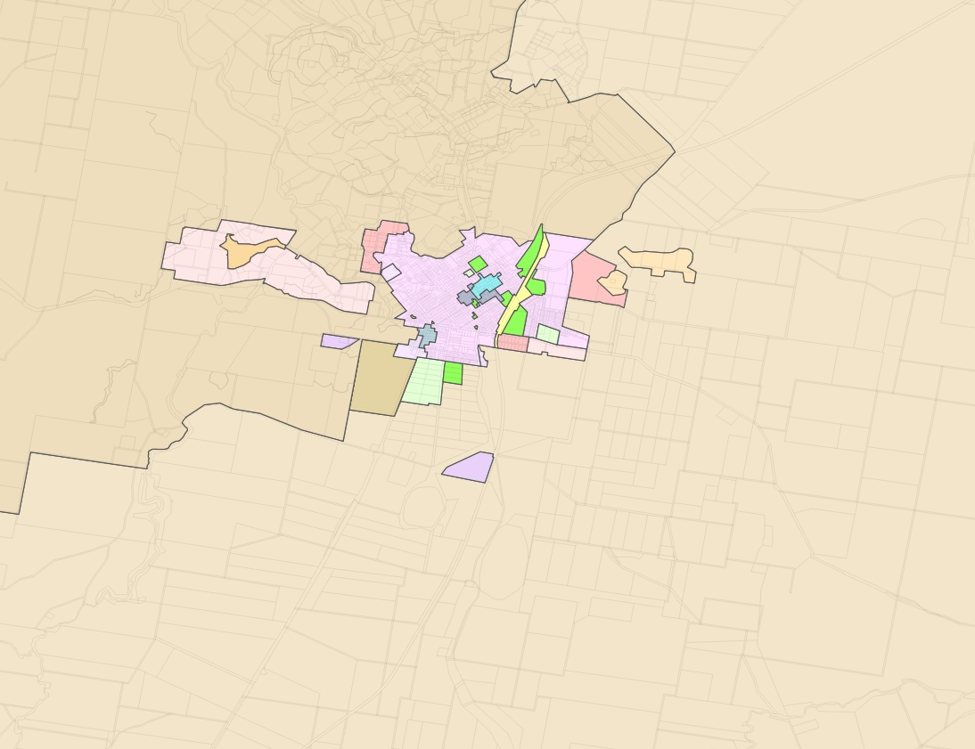

Figure 3. Current Land Zoning (Source: NSW Planning Portal)

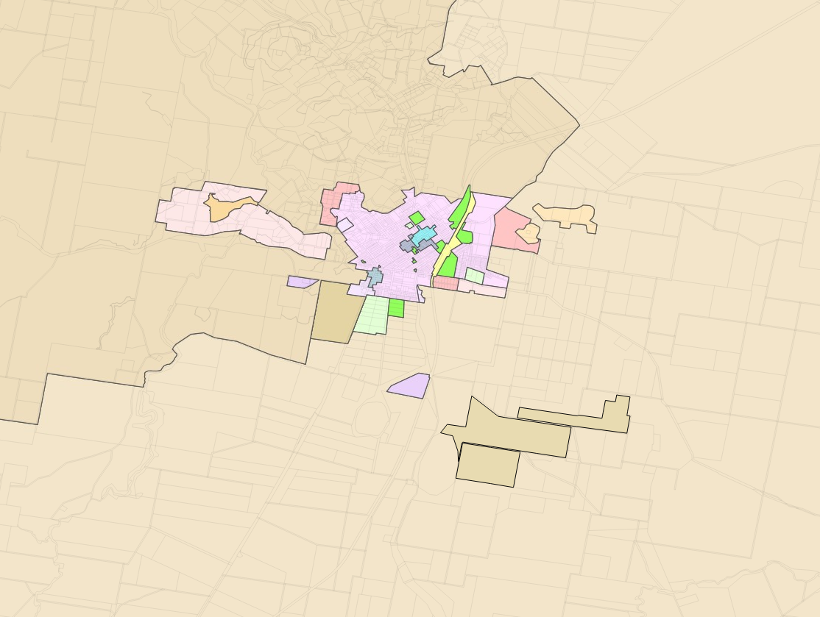

Figure 4. Proposed Land Zoning

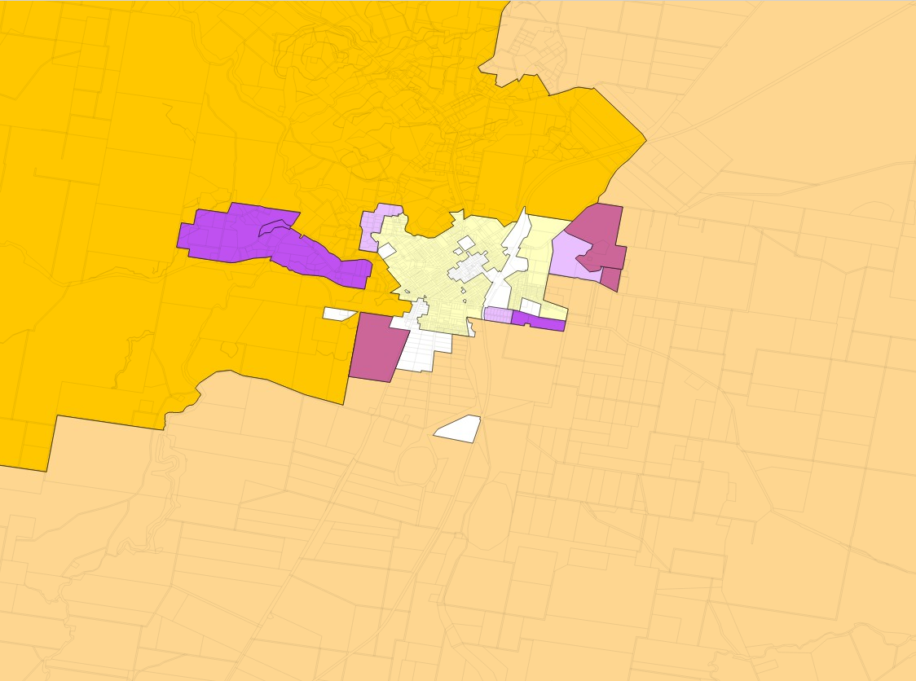

Figure 5. Current Minimum Lot Size Standards (Source: NSW Planning Portal)

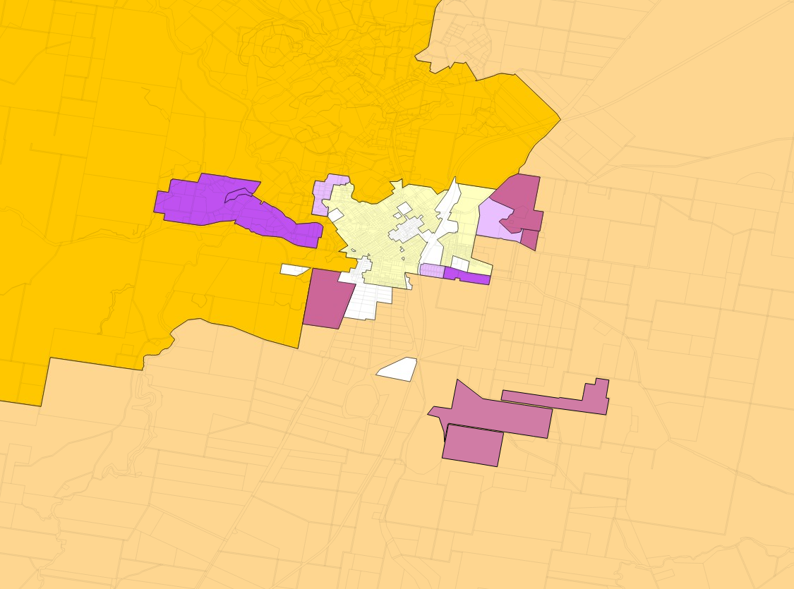

Figure 6. Proposed Minimum Lot Size Standards

**PART 6 – PROJECT TIMELINE**

The anticipated project timeline for completion of the Planning Proposal is outlined in Table 5.

**Table 5. Planning Proposal Process Outline**

|  |  |  |  |  |  |  |  |  |
| --- | --- | --- | --- | --- | --- | --- | --- | --- |
| **Estimated Timeframe** | **2018** | | | | | | | |
|  | **F** | **M** | **A** | **M** | **J** | **J** | **A** | **S** |
| Report to Council / Resolution to refer to department for Gateway Determination | **X** |  |  |  |  |  |  |  |
| Date of Gateway Determination. |  | **X** |  |  |  |  |  |  |
| Completion of additional information (if required). |  |  | **X** |  |  |  |  |  |
| Government agency consultation (pre and post exhibition - if required by Gateway Determination). |  |  | **X** |  |  |  |  |  |
| Any changes that may be required to the Planning Proposal resulting from additional information and government agency consultations.  If required resubmit altered Planning Proposal to Gateway panel. Revised Gateway determination issued, if required. |  |  |  | **X** |  |  |  |  |
| Commencement and completion dates for public exhibition. |  |  |  |  | **X** | **X** |  |  |
| Consideration of submissions, Planning Proposal post exhibition. |  |  |  |  |  |  | **X** |  |
| Date of submission of proposal to Department to finalise the LEP. |  |  |  |  |  |  |  | **X** |

**PART 7 – CONCLUSION**

The subject Planning Proposal is a relatively minor matter that will result in the most logical and appropriate use of an already fragmented rural property that is well located in terms of proximity to the township of Uralla.

This Planning Proposal relates to Lots 29, 61, 119-120, 122-123, 255, 401-409, 415-416, 491 in DP 755846, Lot 1-2 in DP 167083 and Lot B in DP 400556, The Gap Road, Uralla. It is proposed to rezone the land from RU1 Primary Production to RU4 Small Primary Production Lots and to reduce the current minimum lot size of 200 hectares to 20 hectares.

As demonstrated in this report, the Planning Proposal is consistent with the objectives of the relevant Council’s Strategic Planning reports, relevant State Environmental Planning Policies and relevant Section 117 Ministerial Directions, and relevant State Environmental Planning Policies.

It is requested that Council seek a Gateway Determination from NSW Planning and Environment (P&E) requesting permission to place the Planning Proposal on public exhibition.